**MOBILE TECHNOLOGY LAB – PROJECT SYNOPSIS**

2gether - A Personalized Social Media Messenger Application

Project progress report submitted

to

## MANIPAL ACADEMY OF HIGHER EDUCATION

For Partial Fulfillment of the Requirement for the

Award of the Degree

of

Bachelor of Technology

in

Computer and Communication Engineering

By

Deepanjan Dey - 210953248

Suyash Pal - 210953256

Utkarsh Shukla - 210953350

Under the guidance of

Mrs. Vibha and Dr. Manoj Tolani

Assistant Professor - Senior Scale

Department of I & CT

2Gether

March 2024

**1. Introduction**

"2gether" is envisioned as a comprehensive social media messenger application designed to cater to the modern user's need for personalized and interactive communication. In response to the evolving landscape of digital interactions, "2gether" seeks to bridge the gap between existing social media platforms by offering a holistic solution that integrates robust messaging capabilities with intuitive user experience design.

At its core, "2gether" is not just another social media app; it's a platform meticulously crafted to facilitate genuine connections and meaningful conversations among users. By prioritizing user-centric design principles and innovative features, "2gether" aims to redefine the way individuals engage and interact in the digital realm.

Central to the ethos of "2gether" is the commitment to providing a seamless and intuitive interface that enhances user experience and fosters engagement. Through careful attention to detail and a focus on usability, the application endeavors to create an environment where users feel empowered to express themselves freely and connect with others authentically.

As the digital landscape continues to evolve, "2gether" stands poised to revolutionize the social media space by offering a dynamic and personalized communication platform that adapts to the needs and preferences of its users. With "2gether," users can expect more than just a messaging app; they can anticipate a transformative social experience that brings people together in meaningful ways.

**2. Problem Definition**

The "2gether" social media app report aims to address the challenges inherent in existing social media platforms by providing a comprehensive overview of the problems it seeks to solve. In today's digital landscape, social media applications dominate the way people communicate, share content, and build connections. However, despite their widespread usage, these platforms often fall short in fostering meaningful interactions and seamless communication among users.

One of the primary issues prevalent in existing social media platforms is the prevalence of superficial interactions over genuine connections. Users frequently engage in activities such as likes, shares, and emojis, which prioritize quantity over quality. This emphasis on superficial engagement results in a lack of meaningful interactions and a sense of disconnection among users.

Additionally, many social media platforms offer fragmented communication channels, making it difficult for users to transition seamlessly between different modes of communication. This fragmentation leads to disjointed user experiences and can hinder effective communication among users.

Privacy concerns also loom large in the realm of social media, with users increasingly wary of sharing personal information and conversations due to the risk of data breaches and unauthorized access. The lack of robust privacy measures on many platforms further exacerbates these concerns, undermining user trust and confidence in the platform.

Moreover, the complexity of user interfaces on existing social media apps poses a significant barrier to user adoption and engagement. Cluttered interfaces and overwhelming features contribute to a steep learning curve for new users, ultimately detracting from the overall user experience.

Lastly, the limited options for customization and personalization on existing social media platforms fail to cater to the diverse preferences and interests of users. A one-size-fits-all approach often leaves users feeling alienated and dissatisfied with their experience on the platform.

In light of these challenges, the "2gether" social media app aims to redefine the social media experience by prioritizing user-centric design principles, intuitive navigation, robust privacy measures, and innovative chat features. By addressing these core issues, "2gether" seeks to emerge as a preferred choice for individuals seeking authentic connections and meaningful interactions in the digital age.

**3. Objective**

The primary objective of the "2gether" application is to redefine social media messaging by transcending the conventional paradigms of digital interaction. Through a multifaceted approach, "2gether" aims to foster a digital environment characterized by meaningful conversations, authentic personal expression, vibrant community building, and unparalleled user experience.

Central to this objective is the cultivation of meaningful conversations. "2gether" endeavors to create a space where users feel encouraged and empowered to engage in substantive discussions, exchange ideas, and forge genuine connections with others. By providing a platform that prioritizes depth and quality in interactions, "2gether" seeks to counteract the superficiality often associated with traditional social media messaging.

In parallel, "2gether" places a strong emphasis on personal expression, recognizing the importance of allowing users to share their thoughts, feelings, and experiences authentically. Through innovative features and intuitive tools, the application enables users to express themselves creatively, whether through text, images, videos, or other multimedia content. By celebrating individuality and diversity, "2gether" strives to create a welcoming space where every voice is heard and valued.

Moreover, "2gether" is committed to fostering community building within its platform. By facilitating connections based on shared interests, beliefs, and experiences, the application aims to cultivate vibrant communities where users can find support, inspiration, and camaraderie. Whether through public discussions, group chats, or event collaborations, "2gether" provides the infrastructure for users to forge meaningful relationships and cultivate virtual communities that mirror real-world connections.

Integral to achieving these objectives is the relentless pursuit of enhancing user experience. "2gether" is dedicated to providing a seamless, intuitive, and enjoyable interface that caters to the diverse needs and preferences of its user base. From streamlined navigation to personalized recommendations, every aspect of the application is designed to optimize user engagement and satisfaction.

Ultimately, "2gether" aspires to become more than just a social media messaging platform—it aims to become a trusted and beloved digital companion where users can truly connect, engage, and thrive in a digital world. By embodying the core objectives of facilitating meaningful conversations, encouraging personal expression, promoting community building, and enhancing user experience, "2gether" seeks to redefine the landscape of social media messaging and empower users to forge deeper, more meaningful connections in an increasingly interconnected world.

**5. Methodology**

1. Project Planning and Requirements Gathering:

- Conduct initial meetings to outline project objectives, scope, and requirements.

- Define features and functionalities based on user needs and market analysis.

- Establish project timelines, milestones, and resource allocation.

1. Technology Selection:

- Evaluate various development frameworks and technologies.

- Choose Flutter for its cross-platform compatibility, allowing for efficient development across iOS and Android platforms.

- Select additional tools and libraries for implementing chat features, real-time updates, and social media integration.

1. Design and Prototyping:

- Collaborate with UI/UX designers to create wireframes and prototypes.

- Design intuitive user interfaces that prioritize ease of use and engagement.

- Seek feedback from target users and iterate on designs to refine the user experience.

1. Development:

- Divide the development process into sprints, each focusing on specific features or functionalities.

- Utilize Flutter's modular approach to develop components such as chat interface, user profiles, feed display, and online status indicators.

- Implement real-time communication functionalities using WebSocket or Firebase for seamless chat experiences.

- Integrate social media APIs to access online status and view posts from friends within the app.

- Implement features for user authentication, privacy settings, and data security to ensure user trust and compliance with regulations.

1. Testing and Quality Assurance:

- Conduct rigorous testing at each stage of development to identify and rectify bugs, glitches, and performance issues.

- Perform unit testing, integration testing, and user acceptance testing to validate functionality and usability.

- Solicit feedback from beta testers and members of the global community to identify areas for improvement.

1. Deployment and Launch:

- Prepare for app deployment by creating developer accounts on relevant app stores (e.g., Google Play Store, Apple App Store).

- Follow platform-specific guidelines and best practices for app submission and review.

- Coordinate marketing efforts to generate buzz and anticipation for the app launch.

1. Post-Launch Support and Maintenance:

- Monitor app performance and user feedback post-launch to identify any issues or areas for optimization.

- Release updates and patches as needed to address bugs, introduce new features, and improve overall user experience.

- Maintain communication channels with users to address inquiries, gather feedback, and foster community engagement.

8. Continuous Improvement:

- Establish mechanisms for ongoing evaluation and improvement based on user feedback, market trends, and technological advancements.

- Plan for future iterations and enhancements to further refine the app's features, expand its user base, and solidify its position in the market.

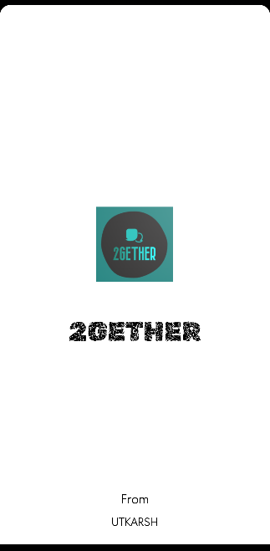 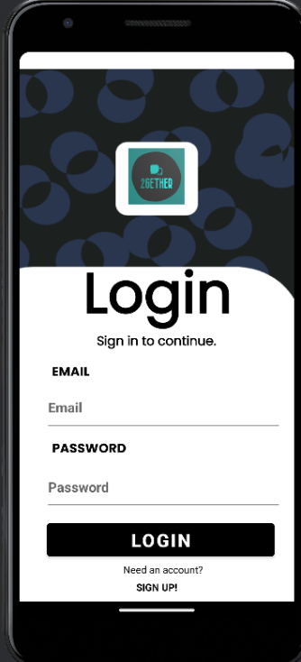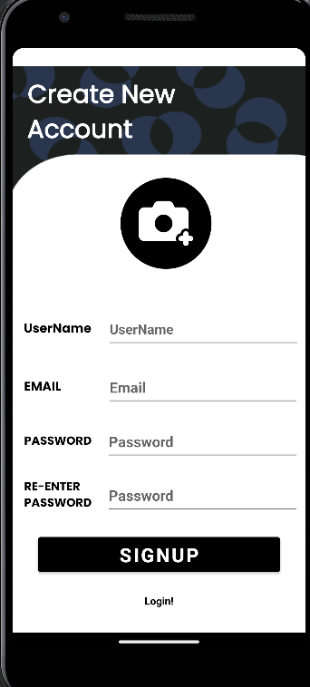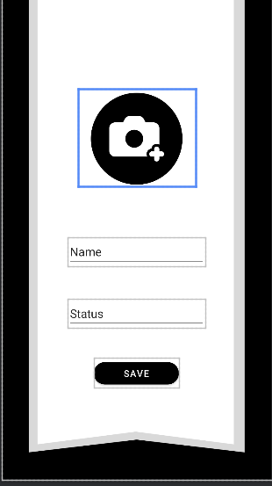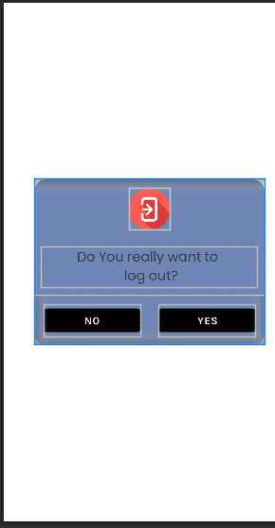

**6. Workdone So Far**

As of the present date, substantial progress has been made in the development of the "2gether" social media messaging application. Leveraging the Flutter framework, significant strides have been achieved in implementing core functionalities that mirror those of established social media platforms. Notably, the inclusion of features such as online status indicators, user-generated posts, and a dynamic feed has been successfully integrated into the application's framework. This progress underscores the commitment to creating a platform that not only facilitates real-time communication but also cultivates a sense of community and engagement among users. Moreover, active collaboration with both the development team and the global user base has been instrumental in shaping the app's evolution, with valuable insights and suggestions being incorporated to enhance usability and functionality. As the development journey continues, the focus remains on refining existing features, incorporating additional functionalities, and ensuring a seamless user experience, ultimately positioning "2gether" as a compelling contender in the realm of social media messaging apps.

Authentication, login, sign up and splash screen functionalities also has been added.

**8. Scope**

The scope of the project "2gether" is extensive, aiming to develop a social media messenger application tailored for Android devices utilizing Android Studios, Flutter, and Firebase technologies. The overarching objective is to create a dynamic platform that transcends traditional social media paradigms, offering users a personalized space to connect with friends, family, and other users in a meaningful and engaging manner. The application's scope encompasses a wide range of features and functionalities designed to facilitate seamless communication, foster genuine engagement, and cultivate a vibrant online community.

Beneficiaries of the "2gether" app span a diverse spectrum of users, each poised to derive value from its unique offerings. Firstly, individuals seeking to connect with friends and family will benefit from the platform's user-friendly interface and robust messaging capabilities, enabling them to stay connected and share moments in real-time. Moreover, users looking to expand their social network and forge new connections will find "2gether" to be a valuable tool, providing opportunities to discover like-minded individuals and engage in meaningful conversations on shared interests and passions.

Beyond personal connections, businesses and organizations stand to benefit from the app's potential to foster community engagement and facilitate direct communication with customers and followers. With features such as user-generated posts and dynamic feeds, businesses can leverage the platform to share updates, promotions, and announcements, thereby enhancing brand visibility and fostering customer loyalty.

Educators and professionals seeking to collaborate and exchange ideas will also find value in "2gether," utilizing its chat features and group functionalities to facilitate discussions, share resources, and collaborate on projects in real-time. Additionally, individuals seeking support, advice, or mentorship will benefit from the platform's ability to connect them with relevant communities and experts within their field of interest.

In summary, the scope of the "2gether" project extends far beyond mere messaging functionality, encompassing a holistic approach to social media that prioritizes personalization, engagement, and community-building. By catering to the diverse needs of its users, "2gether" aims to become a trusted and indispensable tool for fostering meaningful connections and enriching digital experiences in an increasingly interconnected world.